NAME: Akhil
REG.NO: 192211894
SERIAL NO: 10
COURSE NAME: FUNDAMENTALS OF
COMPUTING
COURSE CODE: CSA5779
SLOT NAME:D

PROGRAM:
1.NUMBER SERIES 1,2,3,4,5,6,7……..N
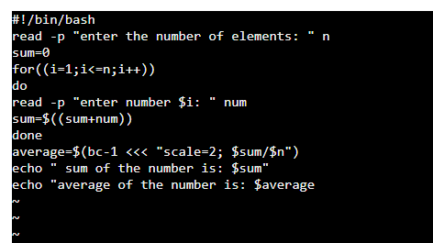
OUTPUT:
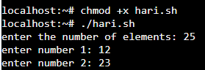

PROGRAM:
2.FINDING NUMBER WHEATHER EVEN OR ODD
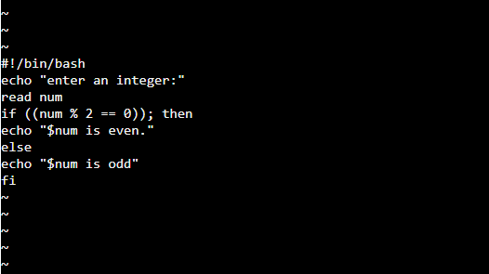
OUTPUT:
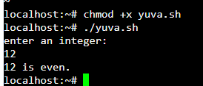

PROGRAM :
3.FINDING A NUMBER WHEATHER NEGATIVE OR POSITIVE
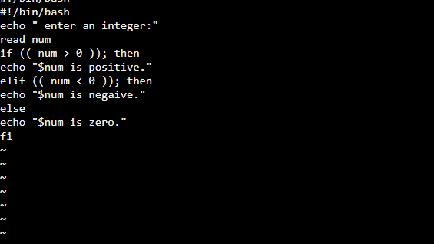
OUTPUT:
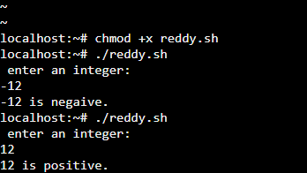

PROGRAM:
4.SUMMING UP THE ODD NUMBER SERIES :
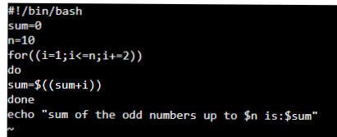
OUTPUT:
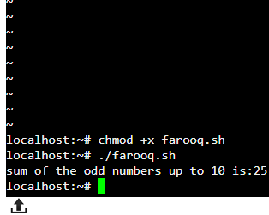

PROGRAM:
5.SWAPPING OF TWO NUMBERS
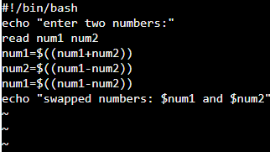

OUTPUT:
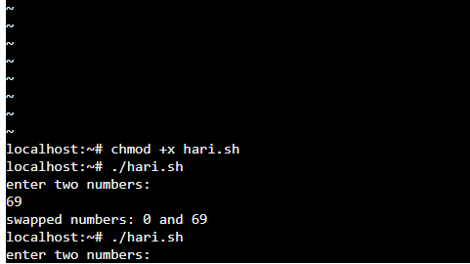

PROGRAM:
6. SUMMING UP EVEN NUMBER SEERIES
INPUT :
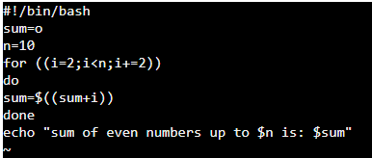
OUTPUT: 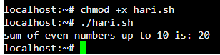

PROGRAM:
7.SWAPPING OF TWO NUMBERS
INPUT:
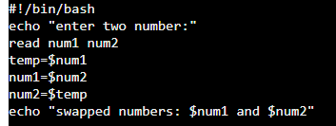
OUTPUT:
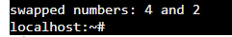

PROGRAM :
8.FINDING A NUMBER WHEATHER ARMSTRONG NUMBER OR NOT :
INPUT:
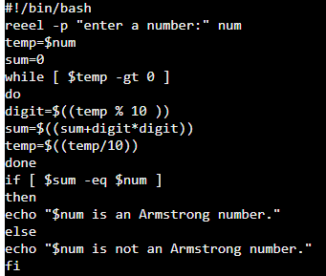
OUTPUT:
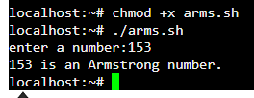

PROGRAM:
9. FINDING BIGGEST NUMBER IN AN INTEGER
INPUT: 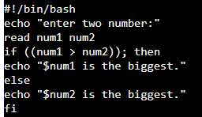
OUTPUT:


PROGRAM:
10.FINDING LARGEST INTEGER FROM GIVEN INTEGERS
INPUT:
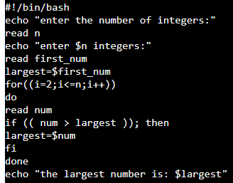
OUTPUT:
